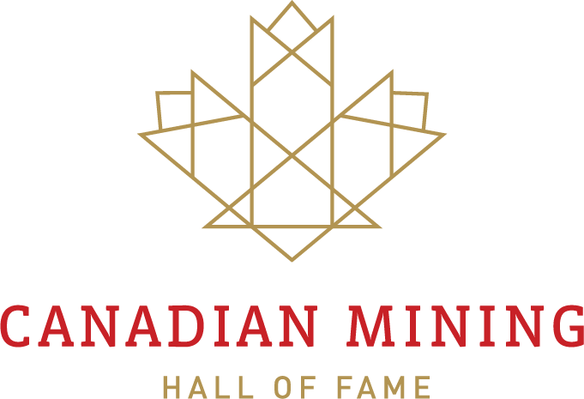

NOMINATION GUIDELINES

Although anyone may nominate a candidate for induction into the Canadian Mining Hall of Fame (CMHF), nominations must be submitted through one of the CMHF member or associate member organizations.

Please contact the member or associate member organization to which you wish to submit a nomination by June 1; and deliver nominating material to the member or associate member organization by June 30. Contact information is included on the following page.

Each nomination must contain the information in the attached form.

While completeness and accuracy are important, submissions should at the same time be as concise as possible. A maximum length of ten pages per nomination is suggested, not including letters of support.

The member organization will submit the documentation to the CMHF. The closing date for receipt of nominations by the CMHF is July 20.

Selection of the individuals to be inducted will be made by the CMHF Board of Directors, whose decision will be final. Selection will be based solely on the Criteria for Selection. Unsuccessful nominations are returned.

Nominations may be submitted up to three times but must be submitted through a member organization each time.

MEMBER AND ASSOCIATE MEMBER ORGANIZATIONS

Member Organizations Associate Member Organizations

Canadian Institute of Mining, Metallurgy & Petroleum
855-3400 de Maisonneuve Blvd.W.
Montreal, Quebec H3Z 3B8

Contact: Angela Hamlyn

E-mail: ahamlyn@cim.org
p: (514) 939-2710 ext. 1301

Mining Association of Canada

275 Slater Street, Suite 1100
Ottawa, ON K1P 5H9

Contact: Danielle Nantais

E-mail: dnantais@mining.ca
p: (613) 233-9392 x223
f: (613) 233-8897 w: www.mining.ca

Prospectors & Developers Association of Canada

800 – 170 University Avenue
Toronto, Ontario M5H 3B3

Contact: Kristy Kenny

E-mail: kkenny@pdac.ca
P: (416) 362-1969 x 233
f: (416) 362-0101 w: www.pdac.ca

The Northern Miner
225 Duncan Mill Road, Suite 320
Toronto, Ontario M3B 3K9

Contact: Anthony Vaccaro

E-mail: avaccaro@northernminer.com
p: (416) 510-6789
f: (416) 510-5138 w: www.northernminer.com

Association for Mineral Exploration (AME)

Suite 800 - 889 West Pender Street
Vancouver, BC V6C 3B2

Contact: Kendra Johnston

Email: kjohnston@amebc.ca
p: 604-630-3920
f: (604) 681-2363 w: www.amebc.ca

Mining Association of British Columbia
Suite 910, 1111 Melville St.
Vancouver, BC V6E 3V6

Contact: Michael Goehring

E-mail: mgoehring@mining.bc.ca
p: (604) 681-4321 x120
f: (604) 681-5305 w: www.mining.bc.ca

Ontario Mining Association

5775 Yonge Street, Suite 520
Toronto, Ontario M2M 4J1

Contact: Chris Hodgson

E-mail: chodgson@oma.on.ca
p: (416) 364-9301
f: (416) 364-5986 w: www.oma.on.ca

Quebec Mining Association
2590, boulevard Laurier
Place de la Cité - Tour Belle Cour
Bureau 720, 7e étage
Québec (Québec) G1V 4M6

Contact: Josée Methot

E-mail: jmethot@amq-inc.com
p: (418) 657-2016 poste 105
f: (418) 657-2154 w: www.amq-inc.com

Saskatchewan Mining Association
Suite 610 - 2220 12th Avenue
Regina, Saskatchewan S4P 0M8

Contact: Pamela Schwann
p: (306) 757-9505
f: (306) 569-1085 w: www.saskmining.ca

NOMINATION FORM

Candidates for induction into the Canadian Mining Hall of Fame must be individuals who have demonstrated outstanding lifetime achievements to the benefit of the Canadian and/or world mineral industry in one or more of the categories outlined below.

Whether the benefit is to the Canadian and/or world mineral industry, there must have been a flow-back of significant benefit to Canada.

A lifetime of service to the industry will normally be evaluated after the individual has reached the age of 65 years or is deceased. Candidates need not be Canadian citizens.

Date:

Section 1: Nominator

Name:

Address:

Phone: Email:
Sponsoring Organization:
 CIM |  PDAC |  QMA
 MAC |  MABC |  SMA
 The Northern Miner |  OMA |  AME BC

Section 2: Nominee Information

Name:

Address:

Phone: Email:

Date of Birth: City of Birth:

Nationality:

If deceased, next of Kin:
Name:

Address:

Phone: Email:

Section 3: Category (ies) of Achievement

Please check all categories of achievement that apply to your nominee.

 EXPLORATION
 Discovered one or more “elephant” deposits of the nature of Horne, Sullivan, Kidd Creek, etc.;
 Discovered a number of significant mines of one or more types;
Introduced a successful theory or principle or exploration technique that had a major impact on the subsequent discovery of significant mines;
 Overcame exceptional obstacles or difficulties (weather, isolation, opposition, etc.) in the discovery of one or more significant mines.

 BUILDING THE CORPORATION
 Exercised outstanding acumen in assembling several properties which formed the basis of a successful Canadian mining company;
 Assembled an outstanding team of individuals to carry on the work of building a major corporation;
Demonstrated entrepreneurial skill and innovative strategy in plotting the direction of the firm;
Displayed unusual managerial capability in directing one or more corporations over a career involving management of change, revitalization, etc.;
Directed the development and start-up of several operating mines under difficult circumstances, including ground conditions, climatic conditions, etc.;
Built an outstanding company providing goods and/or services to the mining industry.

 TECHNICAL CONTRIBUTION
Developed and/or implemented one or more technologies or operating methods that have had a profound impact on the firm, a major mine, operating practice and beyond;
Developed instrumentation, equipment or other devices which contributed to the efficiency, health and safety and/or environmental performance of the exploration and mining industry;
Provided geoscience data or scientific knowledge.

SUPPORTING CONTRIBUTION
 Made an outstanding contribution, in the case of an individual associated with the mineral industry, in such areas as:
 education or professional development;
 supportive public policies or government programs;
 communications and information.

MINING IN SOCIETY
 Demonstrated outstanding achievement in reconciling the business goals of the industry to those of Canadian society in general, through such means as:
 support for worthy cause;
 public understanding of mining;
 environmental improvement;
 improved governmental relations;
 employment of indigenous people;
 building bridges of understanding to other segments of Canadian society.
Section 4 Nominee Contributions

Provide a full description of how the nominee has contributed to all the categories of achievement indicated above (use additional pages if required).

Section 5 Supporting Documentation

Please provide all of the following information as separate documents.

- Curriculum Vitae/Career History
- List of Memberships in Professional and Industry Associations
- List of Publications
- A description of awards and other recognition
- Supporting Letters (minimum of 6)
- Any other information in support of the nominee

